Research on Female-Oriented Mobile Games
Abstract
As the female-oriented mobile gaming market enters a phase of saturated competition, user acquisition costs continue to rise, making long-term user value the decisive factor in a product's commercial success. Optimizing acquisition and retention strategies within limited resources has become a core challenge for game development and operations teams. This study uses global iOS and Google Play data from Sensor Tower, selecting 1,155 games ranked within the top 5,000 cumulative downloads over the past two years with over 60% female player demographics. A comprehensive dataset encompassing seven feature variables—publisher, genre, art style, gameplay type, game setting, update frequency, and business model—was constructed.
Methodologically, this study employs a multi-model comparative strategy: using random forests as the primary attribution model, gradient-boosted trees for performance optimization, logistic regression to validate feature influence directions, and naive Bayes as the baseline model. Through predicting key metrics—including 30-day launch downloads, cumulative downloads over two years, and 1-day, 7-day, 14-day, 30-day, and 60-day retention rates—alongside feature importance analysis, the study reveals core drivers of user acquisition and retention, alongside their dynamic evolution across retention cycles. Experimental findings indicate: 1) The female-oriented mobile gaming market exhibits an oligopolistic brand structure, where publisher strength decisively influences both acquisition and retention; 2) User acquisition is primarily driven by dominant publishers and thematic appeal, while art style and game setting contribute marginally to initial downloads; 3) Retention hinges critically on engaging gameplay types and consistent content update frequency, with the 14-30 day period constituting the pivotal retention test phase; 4) Feature importance dynamically shifts across retention cycles: publisher dominance prevails initially, gameplay and update frequency peak during mid-retention, while brand effect rebounds during long-term core user retention.
Based on these findings, this study proposes resource allocation and operational optimization recommendations for female-oriented mobile games: during project initiation, prioritize validating thematic appeal; during development, enhance core gameplay depth and content production capacity; and design sustained content incentive strategies for the mid-retention phase. The research outcomes not only provide quantifiable commercial decision-making support for game developers but also enrich user behavior research methodologies through multi-model feature importance analysis, offering a new reference framework for precision operations and strategic planning in mobile gaming.

Keywords: Female-oriented mobile games; User acquisition; User retention; Feature importance; Dynamic attribution;

- Commercial Understanding
  - Research Backgrounds and Business Pain Points
As female-oriented mobile games enter a phase of saturated competition, customer acquisition costs (CAC) continue to rise, making long-term user value (LTV) increasingly pivotal in determining commercial success. Within this context, "acquisition" and "retention" stand as the twin pillars for measuring a product's market reach and enduring value. However, significant operational challenges persist in practical implementation.
Firstly, resource allocation faces high uncertainty. During project initiation and early product design phases, critical decisions regarding genre selection, art style, narrative tone, and distribution channels prove difficult to quantify into comparable input-output metrics. This hinders teams from evidence-based prioritization, heightening risks of misallocated or fragmented resources.
Secondly, long-term operations suffer from blind spots. Enterprises lack systematic insights into critical user attrition points and their underlying drivers, particularly the ability to map intangible experiences like "emotional connection" and "plot immersion" to observable behavioral traits. Consequently, retention strategies often rely on experience or superficial metrics, making it difficult to achieve stable improvements through refined operations and experimental design. This leads to operational inefficiency, sluggish market responsiveness, and extended investment payback periods. There is therefore an urgent need to translate experiential variables linked to emotional narratives into quantifiable behavioral metrics. These should be validated through multi-model testing and business-oriented verification to guide resource allocation and optimize retention strategies.
1.2 Data Mining Objectives
1.2.1 Acquisition Analysis: Construct predictive models to identify the most predictive feature variables for a game's 30-day download volume upon launch and its cumulative 2-year download volume, quantifying their contribution.
1.2.2 Retention Analysis: Construct predictive models to forecast 1-day, 7-day, 14-day, 30-day, and 60-day retention rates, revealing the dynamic evolution of feature importance as retention periods extend.

- Literature Review
2.1 Research Backgrounds of Female-Oriented Mobile Games
Existing academic discourse on female-oriented mobile games primarily centres on cultural studies and user experience perspectives, focusing on female players' gaming motivations, emotional investment mechanisms, gender representations, and community practices surrounding gameplay. Related research consistently indicates that unlike traditional game genres emphasizing competitiveness or operational intensity, female-oriented mobile games rely more heavily on emotional connections, narrative immersion, and character relationship building to sustain player engagement.
For instance, Liang Liu et al., drawing upon quasi-social relationship theory, discovered that the emotional projection and sense of companionship formed between players and virtual partners in otome games constitute a crucial psychological foundation driving long-term engagement and monetization. The ongoing development of character relationships, the pacing of plot progression, and interactive feedback mechanisms collectively form key sources of players' emotional immersion. Similarly, Yunrong Han and Xingyu Wang note from a typological perspective that female-oriented games typically enhance character artistry, textual narrative, and emotional experiences in their product design, with their commercial logic heavily reliant on sustained user emotional investment rather than short-term stimulation.
However, existing research predominantly employs qualitative methods such as textual analysis, interviews, or case studies. While these aid in revealing the intrinsic logic of emotional mechanisms, they exhibit notable methodological limitations: on the one hand, conclusions are often based on small samples or single products, limiting their generalizability; on the other hand, core concepts such as emotional interaction and narrative immersion have yet to be systematically translated into observable, quantifiable behavioral metrics, making it difficult to connect with actual user behavior data or predictive models. This gap is particularly pronounced in the current industry context where female-oriented mobile games have entered a phase of saturated competition and refined operations have become the mainstream.
2.2 Drivers of User Acquisition and Retention
Within the broader field of mobile gaming research, a relatively mature empirical framework has emerged concerning the factors influencing user acquisition and retention. Kim et al., using large-scale game log data, distinguished between the distinct driving mechanisms for short-term and long-term retention. They identified that Day 1 Retention primarily depends on the First Time User Experience (FTUE), onboarding processes, and operational fluidity. Conversely, medium-to-long-term retention (such as Day 30 and beyond) relies more heavily on content depth, update frequency, and the sustained appeal of social systems. Multiple studies further indicate that social interaction is one of the key factors in enhancing retention rates. Players engaging in collaborative gameplay (such as teaming up, interacting with friends, or participating in community events) exhibit significantly higher probabilities of re-launching the game compared to solo players. Concurrently, gamified designs—including reward mechanisms, achievement systems, and leaderboards—have been proven to extend user lifecycles by amplifying feedback loops and competitive awareness. It should be noted, however, that most of the aforementioned research used casual or social games as samples, and its conclusions may not universally apply to female-oriented mobile games. Social and interactive elements in female-oriented mobile games typically centre not on competition between real players, but rather on maintaining relationships between players and virtual characters within narrative worlds. Consequently, directly applying generic retention models risks overlooking the unique pathways of “emotional interaction” and “narrative-driven behavior” within this genre. This underscores the necessity of incorporating behavioral variables and interpretative frameworks more attuned to female-oriented mobile games, building upon existing retention theory frameworks.
2.3 The Application of Data Mining and Feature Importance Analysis in Mobile Gaming
At the methodological level, game data mining research has been extensively applied to retention, churn, payment prediction, and user lifetime value (LTV) assessment. Existing literature typically combines logistic regression, tree models (such as Random Forest and XGBoost), and deep learning models to model and compare high-dimensional behavioral features. Lee et al. and Periáñez et al. demonstrated through competition data and commercial log data that ensemble learning methods exhibit high stability and predictive performance in churn prediction. However, as model complexity increases, “model interpretability” has progressively become a critical issue in empirical research. Rajbahadur et al. systematically compared various feature importance methods (including model-embedded importance, permutational importance, and SHAP values), revealing significant inconsistencies between different interpretative approaches. This inconsistency renders research conclusions vulnerable at the interpretative level. This finding is particularly pertinent for mobile gaming research oriented towards business decision-making: if feature importance results lack consistency or verifiability, their guidance for product optimization and resource allocation becomes limited.
Consequently, recent research increasingly emphasises cross-Consequently, recent research has increasingly emphasized cross-validation through multiple models and interpretative approaches, supplemented by secondary verification at the operational level (such as A/B testing) to enhance the robustness and practical applicability of findings. However, within the female-oriented mobile gaming sector, relevant quantitative research remains relatively scarce. Particularly concerning the systematic integration of “soft variables”—such as emotional interaction and narrative engagement—into feature engineering and interpretative frameworks, significant research opportunities persist.
In summary, existing literature has provided relatively thorough theoretical discussions on the emotional mechanisms and cultural characteristics of female-oriented mobile games. Nevertheless, a methodological gap persists in the form of insufficient quantitative research. This study endeavors to bridge this gap. It draws upon conceptualizations of emotional interaction from cultural and user experience research while employing multi-model comparisons and feature importance analysis to translate these concepts into predictable, verifiable behavioral metrics. This approach aims to provide decision support grounded in empirical evidence for the refined operation and long-term value management of female-oriented mobile games.
- Data Interpretation
3.1 Data Collection
All primary data used in this study was sourced from Sensor Tower. This platform, through continuous monitoring of the global iOS App Store and Google Play, provides highly accurate estimates of application downloads, revenue performance, and market trends, thereby supporting extensive academic research and industry analysis.
To ensure the practical relevance and timeliness of research conclusions, the data scope is defined as follows: Firstly, in the temporal dimension, continuous data spanning December 2023 to December 2025 is selected to characterize the market dynamics of female-oriented mobile games during the established market phase, while minimizing interference from early-stage products and historical growth periods on analytical outcomes; Second, in terms of geographical scope, a global statistical framework is employed to obtain a more holistic market panorama. This approach avoids structural biases arising from policy, cultural, or channel differences within individual countries or regions, thereby enhancing the universality and robustness of the research conclusions.
3.2 Sample Construction
To ensure the research focused on the “female-oriented gaming” market while meeting the rigorous requirements for sample size in statistical analysis, we established the following selection criteria to construct the core dataset for this project, comprising a total of 1,155 entries.
3.2.1 Application Category Selection
During the sample construction phase, this study exclusively selected applications officially categorized as “Games” within the Apple App Store and Google Play as research subjects. This screening criterion aims to ensure consistency in product attributes and usage scenarios from the outset, systematically excluding entertainment, social, or utility applications. This approach addresses structural differences in user behavior patterns, monetization logic, and retention mechanisms, thereby preventing non-gaming applications from interfering with subsequent feature extraction and model analysis results. Consequently, it enhances the interpretative validity of research conclusions within the gaming industry context.
3.2.2 Popular Application Selection
Following the application category refinement, further sample scaling is conducted based on market performance. Games ranking within the top 5,000 globally by cumulative downloads over the past two years are selected as research subjects. This criterion ensures the sample possesses sufficient user scale and market activity, thereby enhancing the stability of key metric estimates. Simultaneously, it effectively mitigates issues associated with long-tail applications—such as substantial data noise, elevated estimation errors, and insufficient confidence levels stemming from extremely low download volumes—thereby improving the reliability and interpretative robustness of subsequent statistical analysis and model inference.
3.2.3 User Gender Selection
This study further restricted the sample based on user gender composition, retaining only gaming applications where female players constituted over 60% of the user base. This threshold aligns with the official classification criteria employed by the App Store and Google Play. This screening step ensures the research sample more accurately reflects the core audience characteristics of female-oriented mobile games at the user composition level. It thereby avoids confusion in analyzing behavioral patterns, retention mechanisms, and commercial performance caused by games with highly mixed gender structures, enhancing the specificity and explanatory power of research conclusions within the context of female-oriented mobile gaming.
3.3 Variable System
Variable Type | Field Name |  | Commercial Implications and Modelling Value
Feature Variable | Publisher |  | 【Capital Characteristics】 Refers to a manufacturer's capacity to acquire traffic through channels and its brand endorsement. The model uses this characteristic to learn the weighting of the 'big player effect' on customer acquisition.
Feature Variable | Game Genre |  | 【Content Characteristics】 Refers to specific content tags within games (e.g., farming, cooking). Used to identify high-traffic niche interest points.
Feature Variable | Artistic Style |  | 【Visual Characteristics】 Refers to the game's visual presentation (e.g., 2D anime style, 3D photorealism). Used to validate the contribution of "visual appeal" to conversion rates.
Feature Variable | Game Setting |  | 【Setting Characteristics】 Refers to the game's overarching narrative backdrop (e.g., modern, fantasy). Used to aid analysis of thematic immersion.
Feature Variable | Gameplay Type |  | 【Core Mechanics】 Refers to the foundational gameplay elements of a game (such as simulation management or match-three puzzles). It serves as the pivotal bridge connecting acquisition expectations with retention experiences, determining the user's “first-week experience”.
Feature Variable | Update Frequency |  | 【Operational Productivity Metric】 Refers to the velocity of content output. As a key input to long-term retention models, it validates whether “high-frequency updates” can effectively mitigate veteran player attrition.
Feature Variable | Business Model |  | 【Business Model Characteristics】 Identify the game's core commercial strategy (e.g., hypercasual, mid-core).
Label variable | Acquisition | Downloads in the Previous 30 Days | 【Prediction Objective】  To measure the explosive user acquisition capability during a game's initial launch phase. The study will train a random forest model with this objective to identify the importance ranking of the aforementioned features.
Label variable | Acquisition | Cumulative Downloads Over the Past Two Years | 【Prediction Target】 Reflecting the combined customer acquisition capability of “initial surge + long-tail accumulation”
Label variable | Retention | Day 1 Retention Rate | 【Short-term Objective】Next-day retention rate, primarily gauging the game's “first impression” and “initial user experience”.
Label variable | Retention | Day 7 Retention Rate | 【Short-term objective】 Assess the suitability of gameplay for the novice phase.
Label variable | Retention | Day 14 Retention Rate | 【Mid-Term Objective】 Measures retention during the transition period from novice to experienced players, reflecting the initial effectiveness of game content.
Label variable | Retention | Day 30 Retention Rate | 【Long-term Objective】 Measuring monthly retention serves as a crucial benchmark for determining whether a game possesses a stable user base.
Label variable | Retention | Day 60 Retention Rate | 【Key Objective】 Measure retention among core loyal users to validate the effectiveness of social barriers and long-term operational strategies.

- Data Preparation
4.1 Attribute Reduction
The study rigorously screened the fields within the original dataset, eliminating attributes exhibiting information redundancy or containing single values:
4.1.1 Removal of Redundant Identifiers
Identifier fields such as Unified App ID and Unified Publisher ID have been removed. This is because the original data exhibits a perfect one-to-one correspondence between various IDs and application names (Name). The IDs themselves serve purely technical identification purposes and contain no substantive information useful for commercial interpretation or behavioral analysis. Retaining both ID and name fields would not only introduce information redundancy but could also introduce meaningless variables during feature modelling and importance attribution processes.
4.1.2 Removal of Single-value Attributes
Removal of single-value attributes further eliminated the Platform and Category fields. As this study employs aggregated global data covering both iOS and Google Play, the platform dimension has been consolidated at the data level. Furthermore, the sample was uniformly restricted to the "Game" category during preliminary screening. Consequently, both variables represent constant values across all observed samples. Their removal enhances model efficiency and prevents spurious features from interfering with the analysis process.
4.2 Descriptive Statistical Analysis
4.2.1 Characteristics
Feature Name | Category | Number of Characteristic | The Most Frequently Occurring Feature
Publisher | Nominal | 534 | Take-Two Interactive
Game Genre | Nominal | 73 | Fashion/Aesthetics
Artistic Style | Nominal | 13 | 2D cartoon
Game Setting | Nominal | 6 | Modern
Gameplay Type | Nominal | 62 | Sort
Update Frequency | Nominal | 23 | 12+weeks
Business Model | Nominal | 5 | casual
4.2.2 Acquire Dimension
Label | Minimum Value | Maximum Value | Mean | Variance
Cumulative Downloads Over the Past Two Years | 3317879 | 195438203 | 14932921.131 | 19199263.744
First 30 Days' Downloads | 0 | 40313399 | 1384449.374 | 3619390.496
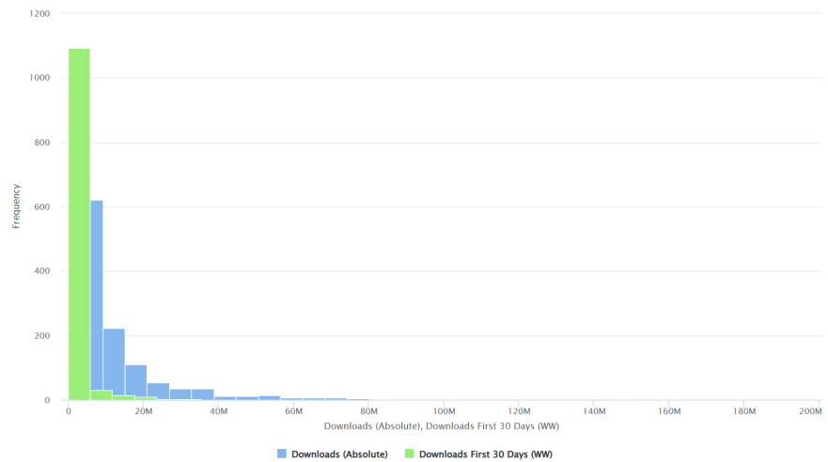
4.2.3 Retention Dimension
Label | Minimum Value | Maximum Value | Mean | Variance
Day 1 Retention | 0.08 | 0.72 | 0.393 | 0.073
Day 7 Retention | 0.02 | 0.55 | 0.12 | 0.057
Day 14 Retention | 0 | 0.45 | 0.074 | 0.046
Day 30 Retention | 0 | 0.34 | 0.042 | 0.034
Day 60 Retention | 0 | 0.23 | 0.024 | 0.024
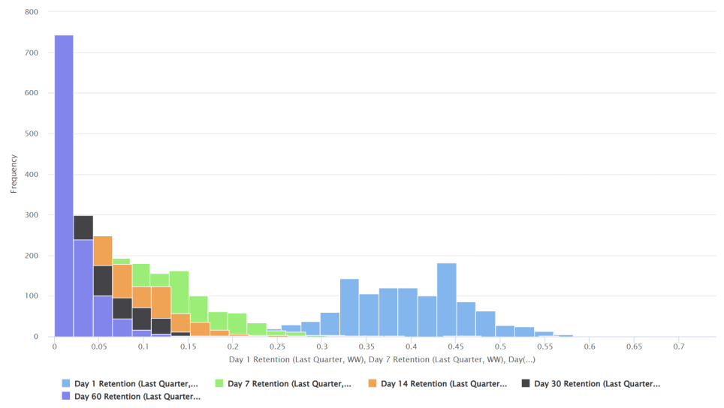

- Modelling and Evaluation
5.1 Experimental Setup
This study conducted modelling and evaluation processes on the RapidMiner platform using cleaned sample data. The target variable was first binarized, dividing the continuous market performance metric into “high performance” and “low performance” categories based on the median. Stratified sampling was employed to partition the dataset into an 80% training set and a 20% test set.
On the training set, we constructed models including Random Forest, Gradient Boosting Tree, Logistic Regression, and Naive Bayes. Random Forest served as the primary attribution model, Gradient Boosting Tree was used for performance comparison, Logistic Regression for directional validation, and Naive Bayes as the baseline model. Following model training, these were applied to the independent test set. Predictive performance was evaluated using confusion matrices and metrics including Accuracy, Precision, and Recall. Feature importance results across different models were compared to assess the robustness and interpretative consistency of conclusions.
5.2 Description of Modelling Algorithms
Given the attributes of the raw data (high-dimensional sparse text labels), this study selected the following four methods:
5.2.1 Random Forest —— [Primary Attribution Model]
Its core concept is based on Bagging, which involves multiple resampling with replacement of training samples and the parallel construction of multiple decision trees. During the prediction phase, the outputs from each sub-model are aggregated using majority voting or averaging results, thereby effectively mitigating the high variance risk associated with a single decision tree.
This algorithm demonstrates robust resilience in high-dimensional, sparse feature spaces exhibiting nonlinear relationships, maintaining stable performance amidst complex feature combinations. Crucially, Random Forests directly output built-in feature importance metrics based on node split contributions. This enables quantitative assessment of relative contributions from factors such as publisher, genre, and art style towards the prediction target, aligning perfectly with this study's attribution objective of identifying core drivers within the female-oriented mobile gaming market.
5.2.2 Gradient Boosted Trees —— [Performance Optimization Model]
Its core mechanism is based on Boosting, which progressively corrects prediction errors by iteratively training new decision trees to fit the residuals generated by the previous round of models, thereby enabling the overall model to continually approximate the true target values.
Compared to the parallel modelling approach of Random Forests, GBT's sequential learning enables more effective capture of complex nonlinear relationships, typically yielding higher predictive accuracy. Consequently, this study selected it as the performance optimization model. On one hand, it enhances predictive performance in classification tasks; on the other, by comparing results with Random Forests, it tests whether the feature importance rankings derived from the primary attribution model exhibit stability and robustness.
5.2.3 Logistic Regression —— [Direction Validation Model]
This method falls under the category of generalized linear models, employing the sigmoid function to map the linear combination of predicted outcomes to probability values between 0 and 1, thereby enabling binary classification tasks.
Compared to non-linear models such as random forests and gradient-boosted trees, logistic regression offers greater interpretability by directly outputting regression coefficients corresponding to each feature. The sign and relative magnitude of these coefficients clearly indicate the directional influence of different art styles, genres, or gameplay labels on the target variable. This allows precise identification of features that positively promote high-performing games versus those that significantly reduce success rates, thereby providing directional validation for the feature importance results obtained.
5.2.4 Naive Bayes —— [Reference model]
This model is based on Bayes' theorem and assumes conditional independence of features under given categories during computation. It performs classification predictions by estimating the conditional probability of feature occurrence across different categories. Although the assumption of feature conditional independence is often difficult to fully validate in real game data, Naive Bayes remains employed as the reference model in this study due to its structural simplicity and computational efficiency.
This study employs it as the baseline to evaluate the informational content of feature engineering itself: should the model achieve reasonable predictive accuracy under strictly simplified assumptions, it indicates that the selected core features such as publisher, gameplay, and genre, possess strong discriminative power. This provides foundational validation for the efficacy of other complex models.
5.3 Modelling Steps and Process
5.3.1 Data Extraction and Preliminary Standardization
First, import the raw data table and standardize variable types. Designate textual labels such as game themes and art styles as nominal variables (Polynominal), while setting continuous metrics like download volumes and retention rates as real variables (Real). This ensures subsequent operators can correctly identify and process data types.
Subsequently, the Select Attributes operator was employed to filter attributes, retaining only core feature variables and target label variables essential for modelling. This prevents irrelevant attributes from interfering with model training.
Finally, the Replace Missing Value operator uniformly handled missing values in the data, filling them with None. This ensures data structural integrity and prevents computational errors during model training caused by missing values.
5.3.2 Feature Engineering and Preprocessing [Applicable to Random Forests and Logistic Regression only]
For nominal variables containing extensive textual labels, this study implemented independent feature engineering processes for both random forest and logistic regression models. Specifically, the Nominal to Numerical operator in RapidMiner was employed, with dummy coding selected as the encoding method, to perform dummy encoding on textual features such as game themes, art styles, and gameplay types.
Through this process, the original text was transformed into a sparse matrix composed of 0/1 values. For instance, the “art style” field was decomposed into binary features such as Art_Style_2D and Art_Style_3D. This enabled the model to quantitatively learn and estimate the independent contribution and weight of each specific label.
5.3.3 Target Variable Restructuring
During initial attempts to directly predict continuous metrics such as download volume using regression models, significant model errors and insufficient predictive stability were observed, rendering the approach inadequate for analytical and interpretative requirements. Consequently, this study adjusted the modelling strategy by reducing the problem dimension from “regression” to “classification”, thereby enhancing model robustness and result interpretability.
In practical terms, the target variable was first grouped using the Discretize operator. The continuous metric to be predicted was divided into two intervals based on the median (number of bins = 2), generating two labels representing high and low levels: range1 and range2. Subsequently, the Nominal to Binomial operator converted these nominal labels into a binary variable format. Finally, the Set Role operator explicitly designates the restructured target variable as the model's prediction label (label), establishing a unified target definition for subsequent classification modelling.
5.3.4 Model Configuration
The model datasets frequently employed in this study were partitioned using stratified sampling, dividing the data into an 80% training set and a 20% test set：
- Random Forest
Operator Placement: number of trees = 100, criterion = gain_ratio, max depth = 10
- Gradient Boosted Trees
Operator Placement: number of trees = 100, maximal depth = 5, min rows = 10, number of bins = 20, learning rate = 0.1, sample rate = 1.0
- Logistic Regression
Operator Placement: stopping rounds = 3, stopping tolerance = 0.001
- Naive Bayes
5.4 Model Application and Performance Evaluation
Upon completion of model training, the Apply Model operator is first employed to apply the trained random forest, gradient-boosted trees, logistic regression, and naive Bayes models to the 20% independent test set, yielding prediction results; Subsequently, the Performance operator evaluates the model outputs, generating a confusion matrix and calculating key classification metrics including accuracy, precision, and recall. This provides a comprehensive assessment of each model's predictive performance and classification capability on the independent samples, thereby establishing a foundation for subsequent feature importance analysis and business interpretation.
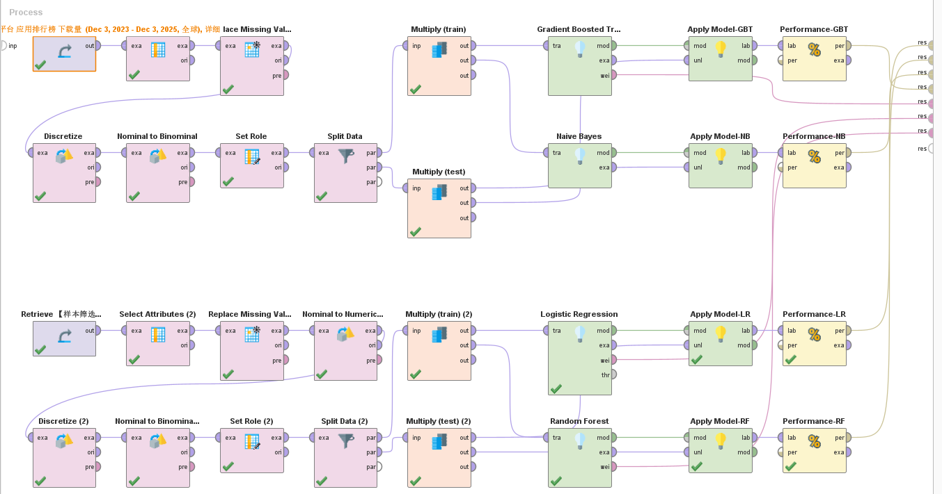
Dimension | Label | Model | Accuracy | Precision | Recall
Acquisition | First 30 Days' Downloads | Random Forest | 64.07% | 59.30% | 88.70%
Acquisition | First 30 Days' Downloads | Gradient Boosting Tree | 64.94% | 61.49% | 79.13%
Acquisition | First 30 Days' Downloads | Logistic Regression | 61.47% | 58.33% | 79.13%
Acquisition | First 30 Days' Downloads | Naive Bayes | 68.83% | 70.09% | 65.22%
Acquisition | Cumulative Downloads Over the Past Two Years | Random Forest | 52.81% | 55.00% | 28.70%
Acquisition | Cumulative Downloads Over the Past Two Years | Gradient Boosting Tree | 59.74% | 57.53% | 73.04%
Acquisition | Cumulative Downloads Over the Past Two Years | Logistic Regression | 58.87% | 57.81% | 64.35%
Acquisition | Cumulative Downloads Over the Past Two Years | Naive Bayes | 57.58% | 58.10% | 53.04%
Retention | Day 1 Retention | Random Forest | 54.98% | 53.80% | 83.90%
Retention | Day 1 Retention | Gradient Boosting Tree | 60.61% | 68.49% | 42.37%
Retention | Day 1 Retention | Logistic Regression | 60.17% | 58.78% | 73.73%
Retention | Day 1 Retention | Naive Bayes | 74.46% | 76.11% | 72.88%
Retention | Day 7 Retention | Random Forest | 63.20% | 59.71% | 98.40%
Retention | Day 7 Retention | Gradient Boosting Tree | 66.67% | 64.46% | 85.60%
Retention | Day 7 Retention | Logistic Regression | 64.94% | 63.25% | 84.00%
Retention | Day 7 Retention | Naive Bayes | 80.09% | 83.76% | 78.40%
Retention | Day 14 Retention | Random Forest | 69.26% | 63.16% | 99.17%
Retention | Day 14 Retention | Gradient Boosting Tree | 71.86% | 67.95% | 87.60%
Retention | Day 14 Retention | Logistic Regression | 68.83% | 65.22% | 86.78%
Retention | Day 14 Retention | Naive Bayes | 82.25% | 87.04% | 77.69%
Retention | Day 30 Retention | Random Forest | 59.31% | 57.47% | 100.00%
Retention | Day 30 Retention | Gradient Boosting Tree | 70.56% | 67.46% | 89.76%
Retention | Day 30 Retention | Logistic Regression | 58.01% | 59.15% | 76.38%
Retention | Day 30 Retention | Naive Bayes | 76.19% | 77.69% | 79.53%
Retention | Day 60 Retention | Random Forest | 64.50% | 64.50% | 100.00%
Retention | Day 60 Retention | Gradient Boosting Tree | 75.32% | 76.14% | 89.93%
Retention | Day 60 Retention | Logistic Regression | 64.07% | 80.00% | 59.06%
Retention | Day 60 Retention | Naive Bayes | 78.79% | 86.23% | 79.87%

- Commercial Deployment
  - Core Elements
This study, through a multi-model comparison of random forests and gradient-boosted trees, yielded consistent findings: publisher strength (brand/distribution channels/user acquisition capabilities) exerts an absolute dominant influence on both user acquisition and medium-to-long-term retention. Gameplay mechanics and content update frequency serve as key drivers for retention (particularly during the 14-30 day period). Genre significantly contributes to initial launch momentum, whereas art style and world-building have relatively limited impact on launch performance during the project initiation phase. In other words, whether a product gains visibility and downloads relies more heavily on publisher capabilities and genre appeal; whether it sustains long-term engagement depends more on gameplay longevity and a stable content pipeline. This conclusion demonstrates robustness across multiple experiments and feature importance metrics.
6.2 High-Potential Themes and Gameplay Recommendations
6.2.1 High-potential Themes
The top five genres are fashion/aesthetics/hairstyles, cooking/culinary arts, home decoration, farm management, and healthcare/emergency services. This reveals that female-preferred genres exhibit characteristics centred on “beauty” and “management”. It is recommended that manufacturers first validate a genre's appeal during project initiation, using prototype testing (short video concepts + small-scale paid/download validation) to assess click-to-install conversion rates within target female segments.
6.2.2 Endurance-based Gameplay
The top five genres are organization/parkour/virtual pets/time management/rhythm games. These genres embody characteristics of “repeatability” and “daily playability”. It is recommended that developers prioritize sustainable gameplay as the core design direction for mid-term retention. This could involve incorporating mini-game features or designing such mini-games within version updates, while ensuring low entry barriers for accessibility and high-level ongoing objectives (such as collection, nurturing, challenges, and social interaction).
6.2.3 Opportunities for Differentiated Innovation
Developers may integrate themes with strong user acquisition potential alongside gameplay mechanics that foster retention, thereby exploring player needs to capture niche markets during the project initiation phase and enhance early conversion rates alongside mid-term engagement.
6.3 Differentiated Analysis of Acquisition and Retention Strategies
6.3.1 Customer Acquisition Strategy
The core objective here is to simultaneously achieve high exposure and high first-day conversion along the shortest possible path. Essentially, this entails rapidly validating the optimal combination of “genre × channel × creative assets” with the lowest possible trial-and-error costs. This goal primarily relies on three key levers: the publisher's access to channels and user acquisition resources (including co-publishing and cross-category placement capabilities), the market receptivity of the genre itself, and a highly market-driven, rapidly iterable creative asset system.
At the operational level, this can be achieved by constructing a Launch Creative Kit. This involves simultaneously producing multiple sets of short videos and static assets around the core theme, enabling rapid A/B testing within small-scale trials to identify the asset versions with the lowest CPI and highest conversion efficiency at the earliest stage. Simultaneously, adopt a multi-channel parallel combination and spillover strategy, synergizing social media short videos, KOL/KOC endorsement, cross-promotion, and paid user acquisition. Localize assets according to cultural and user preferences across different countries and regions to amplify the marginal returns of effective creatives. On the app store front, systematic Store Operations optimisation is required for Store Listings, encompassing keyword strategy, primary image design, and showcase video production to enhance algorithmic recommendation rates and category visibility.
It must be emphasized that this comprehensive customer acquisition strategy relies heavily on the publisher's inherent resource endowment. For small and medium-sized enterprises, insufficient publishing capabilities often constitute a structural constraint. Consequently, a more viable approach involves leveraging joint operation or publishing partnerships, or proactively focusing on niche channels within the long tail that exhibit higher conversion efficiency, thereby achieving relatively robust customer acquisition performance. From our research perspective, a significant portion of uncertainty in customer acquisition forecasting stems from gaps in purchase and placement data. This underscores that in real-world deployment scenarios, continuous real-time monitoring and rapid iteration are not merely supplementary measures but essential prerequisites for mitigating risks and refining model predictions.
6.3.2 Retention Strategy
The core objective is to successfully establish a sustainable gameplay consumption mechanism and stable return pathways during the critical mid-stage period between days 14 and 30, enabling the product to transition from being “novelty-driven” to “habit-forming engagement”. The key levers for achieving this goal lie in the inherent depth of the gameplay itself, the pacing of content updates, and whether the initial content pipeline is robust enough to sustain the mid-stage experience without disruption.
In practice, the core gameplay must first be thoroughly refined to ensure users clearly grasp the task chain structure and phased objectives during the initial 7-day onboarding period, thereby reducing early attrition caused by ambiguous goals or excessive learning costs. Subsequently, establish a stable, predictable mid-game content release schedule—such as weekly, fortnightly, or monthly events—to continually deliver fresh excitement. Prioritize content packs that directly expand gameplay depth rather than merely offering numerical rewards, thereby avoiding retention reliance on “stacked perks”; Building upon this foundation, effective incentive and re-engagement mechanisms must be designed. These should include mid-term objectives (e.g., limited-time collections, milestone completion rewards), social features (friend interactions, leaderboard competitions), and tiered paid/free incentives to address differing motivations across user segments. Finally, retention strategies must be grounded in data-driven operations. Using retention funnel metrics such as D1, D7, D14, D30, and D60, combined with behavioral segmentation (novice, active, returning, high-spending users), enables more targeted push notifications, email campaigns, and event promotions.
The entire suite of retention measures hinges upon the team possessing a predictable and sustainable capacity for content production. Without this capability, the purported update schedule will remain confined to the planning stage, failing to translate into a stable foundation for mid-term retention.
6.3.3 Differentiated Recommendations Tailored to the Varying Capabilities of Different Publishers
Differentiated recommendations for publishers with varying capabilities should be structured through strategic tiering based on resource endowment and risk tolerance.
For dominant publishers, their strengths lie in substantial capital, extensive channel resources, and robust user acquisition expertise. therefore, they can allocate greater budgets towards creative production and cross-channel distribution during the initial launch phase. By conducting high-density, multi-version creative testing, they can pursue rapid short-term visibility and user scale growth. Simultaneously, on the R&D side, they should increase investment in deepening core gameplay and system complexity to ensure sustainable long-term LTV is built upon high customer acquisition volumes, thereby avoiding the scale trap of “high acquisition costs, low retention”.
For smaller or independent teams, constrained by budget and distribution capabilities, a more prudent approach involves prioritizing low-cost validation of themes and gameplay mechanics. This enables the creation of “small but beautiful” products with clearly blended mechanics and focused positioning. By repurposing proven hit formulae from the market and overlaying social interaction or sharing mechanisms to achieve a degree of viral spread, they can amplify organic diffusion within limited resources. This approach avoids the irreversible financial risks of blindly investing in large-scale user acquisition before product validation.
6.4 Recommendations for Resource Allocation and Operational Optimization
6.4.1 Overall Resource Architecture
Approximately 35% of resources are allocated during project initiation and early development to validate thematic appeal and prototype core gameplay mechanics, whilst completing initial user testing. Around 30% is invested during the launch promotion phase, prioritizing creative production and channel distribution, alongside optimizing storefront pages to enhance visibility and conversion rates. Post-launch Live-ops and content production account for roughly 25%, ensuring consistent content refresh cycles and sustained event planning. The remaining 10% is allocated to data and experimentation, covering data engineering, model monitoring, A/B testing, and rapid iteration.
These proportions are not fixed and should be flexibly adjusted based on product development intensity and market positioning. For instance, mid-to-hardcore products may require more upfront research resources, while hyper-casual or short-lifecycle products should correspondingly increase budgets for user acquisition.
6.4.2 Organization and Position Priority
In terms of organizational and role prioritization, core essential roles include the Product Manager (responsible for gameplay and numerical design), front-end and back-end developers, a Chief Data Officer or Data Analyst role (focusing on retention and conversion funnel analysis), Operations personnel (handling event design and community maintenance), and Creative and Art personnel (undertaking asset production and overall visual presentation).
In terms of specific organizational structure, roles may be grouped by function. For instance, a development team comprising designers and artists focuses on product development, while an operations team manages channels and user growth. Concurrently, data roles provide continuous monitoring and feedback on user behavior and operational effectiveness.
6.4.3 Key Performance Indicators and Closed-Loop Optimization Process (Example)
Regarding KPIs and closed-loop optimization processes, efforts should centre on core metric systems and continuous iteration mechanisms.
Key KPIs include D1/D7/D14/D30/D60 retention rates, CPI, ARPDAU, LTV across different timeframes (30/60/90 days), and a retention stratification structure tracking progression from new to active to core users. For optimization, establish daily and weekly data dashboards for monitoring. Use models such as random forests or gradient-boosted trees to periodically output feature importance changes, identifying variables with the greatest impact on core metrics. Design A/B or batch experiments targeting these high-impact factors, translating experimental outcomes into concrete product or operational adjustments. Subsequently, new data is fed back into the model to continuously update and monitor weight drift, thereby forming a closed-loop system of “modelling-experimentation-implementation-remodeling”. This elevates static analysis into a continuously operating decision support system.

- Conclusions
7.1 Research Findings
Conclusion 1: The female-oriented mobile gaming market has evolved into a “brand oligopoly” structure, where publisher strength serves as the primary driver for customer acquisition and retention.
Conclusion 2: The foundational formula for successful customer acquisition is: robust distribution × precisely targeted attention-grabbing themes; the marginal benefits of artistic packaging during the project initiation phase are limited.
Conclusion 3: The foundational formula for retention success is: Powerful Publisher × Enduring Core Gameplay × Consistent Content Updates, with the 14-30 day period being the critical test phase.
Conclusion 4: The importance of each factor dynamically shifts across retention cycles: publishers dominate early retention, gameplay and update frequency peak during mid-retention, while brand influence rebounds in the long term.
7.2 Research Contributions and Implications
7.2.1 Contributions to Academic Methodology
Through multi-model comparison (RF/GBT/LR/NB) and feature importance analysis, this study clarifies the distinct driving mechanisms from customer acquisition to retention in female-oriented mobile games, establishing a replicable quantitative pathway for mobile gaming user behavior research. The methodology validates feature importance robustness via Random Forest and Gradient Boosting Tree models, whilst employing Logistic Regression to analyze positive/negative feature impacts, thereby achieving a balance between model interpretability and predictive performance.
7.2.2 Practical Implications
It provides developers with quantifiable guidance for resource allocation and operational strategy: prioritize small-sample validation of theme-gameplay combinations during project initiation; amplify exposure through distribution/asset optimization during launch; and retain users through gameplay depth and stable content pipelines during retention phases. This approach significantly enhances resource efficiency while mitigating high CPI risks associated with indiscriminate spending.
7.3 Research Limitations and Future Prospects
7.3.1 Limitations
This study relies on publicly available estimates from Sensor Tower (December 2023 to December 2025), which exclude precise user acquisition/advertising expenditure data, platform recommendation algorithm details, and user-level behavioral logs. Consequently, explanations regarding the customer acquisition side may still omit exogenous variables (such as real-time advertising strategies and creative ad effects). Moreover, the model primarily uses observational data, yielding conclusions regarding correlation and predictability rather than establishing causality. Certain features (e.g., “publisher”) may proxy multiple unobserved factors. Additionally, the sample selection criterion (female player proportion >60%) filters out marginal hybrid products, necessitating caution when extrapolating conclusions to “neutral or male-oriented” products.
7.3.2 Future Outlook
In future work, the model's accuracy in causal interpretation can be further enhanced by incorporating more comprehensive user acquisition and ad placement data alongside creative experiment results, combined with attribution correction models such as Uplift Modelling or Causal Impact analysis. Concurrently, acquiring finer-grained user behavior data—such as onboarding completion rates, core gameplay engagement metrics, and social feature usage—will support behavioral pathway analysis. This foundation can then be leveraged for stratified modelling integrated with Lifetime Value (LTV). Furthermore, segmented analysis by platform type (e.g., iOS versus Android) and distinct national/regional markets will systematically validate the model's stability and applicability across multiple market contexts, thereby enhancing the extrapolation value of its conclusions.

References
[1]Kim S, Choi D, Lee E, Rhee W (2017) Churn prediction of mobile and online casual games using play log data. PLoS ONE 12(7): e0180735. https://doi.org/10.1371/journal.pone.0180735
[2]Shender, D., Amini, A. N., Bao, X., Dikmen, M., Richardson, A., & Wang, J. (2020). A Time To Event Framework For Multi-touch Attribution. ArXiv. https://doi.org/10.6339/23-JDS1101
[3]Lee, E., Jang, Y., Yoon, D., Jeon, J., Yang, S., Lee, S., Kim, D., Chen, P. P., Guitart, A., Bertens, P., Periáñez, Á., Hadiji, F., Müller, M., Joo, Y., Lee, J., Hwang, I., & Kim, K. (2018). Game Data Mining Competition on Churn Prediction and Survival Analysis using Commercial Game Log Data. ArXiv. https://doi.org/10.1109/TG.2018.2888863
[4]Periáñez, Á., Saas, A., Guitart, A., & Magne, C. (2017). Churn Prediction in Mobile Social Games: Towards a Complete Assessment Using Survival Ensembles. ArXiv. https://doi.org/10.1109/DSAA.2016.84
[5]Rajbahadur, G. K., Wang, S., Kamei, Y., & Hassan, A. E. (2022). The impact of feature importance methods on the interpretation of defect classifiers. ArXiv. https://doi.org/10.1109/TSE.2021.3056941
[6] Han Yunrong, Wang Xingyu. Tracing the Origins, Analysing the Genres and Patterns of Female-Oriented Games [J]. Modern Communication (Journal of Communication University of China),2020,42(06):141-146.
[7] Liu Liang, Zhang Shuning, Liu Guiyun, et al. A Study on Quasi-Social Relationships Between Players and Virtual Lovers in Otome Games [J]. Science and Technology Communication,2021,13(17):150-154.DOI:10.16607/j.cnki.1674-6708.2021.17.046.
[8] He Ye, Ge Yundi. Research on Female-Oriented Mobile Game Audiences from the Perspective of Usage and Satisfaction: Taking Love and Producer as an Example [J]. Southeast Communication,2020,(04):109-112.DOI:10.13556/j.cnki.dncb.cn35-1274/j.2020.04.032.

